FINAL REPORT

1. Staff:
2. Login:

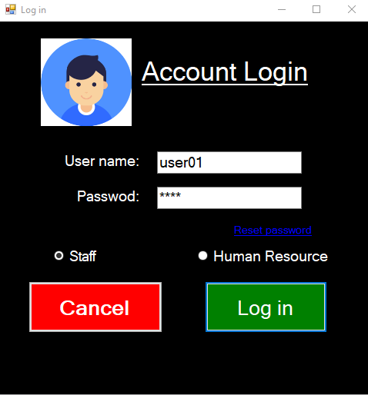

Reset password, send mail to receive OTP:

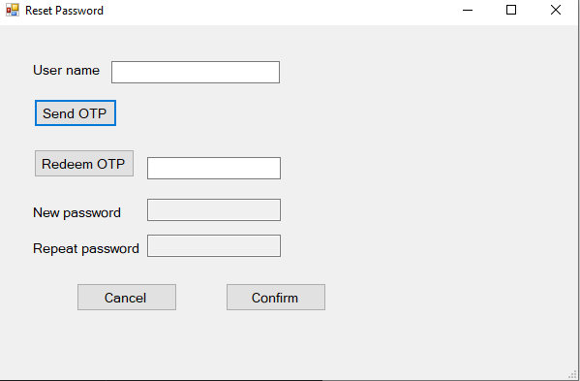

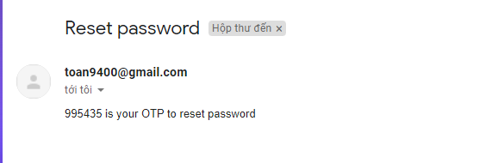

1. 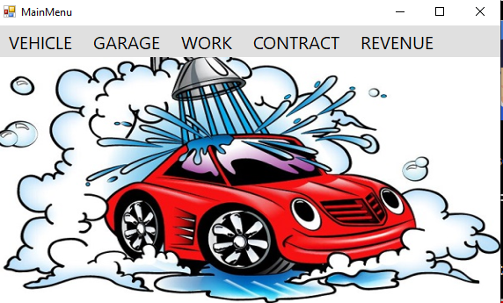Main Menu
2. Vehicle
3. Work
   1. Add work

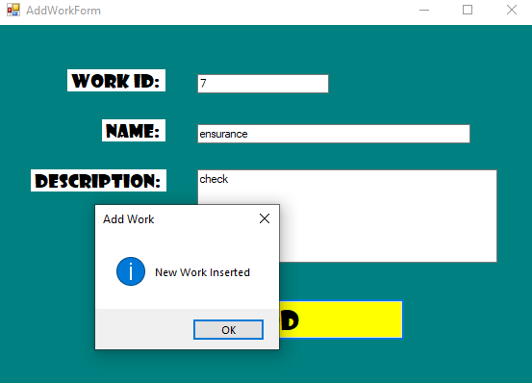

* 1. Remove work

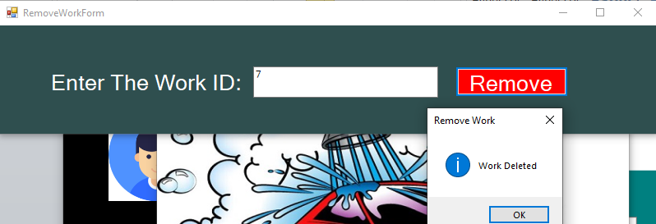

* 1. Update work

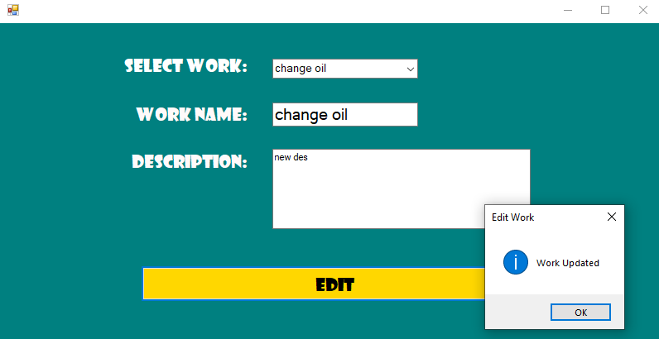

* 1. Manage work

1. 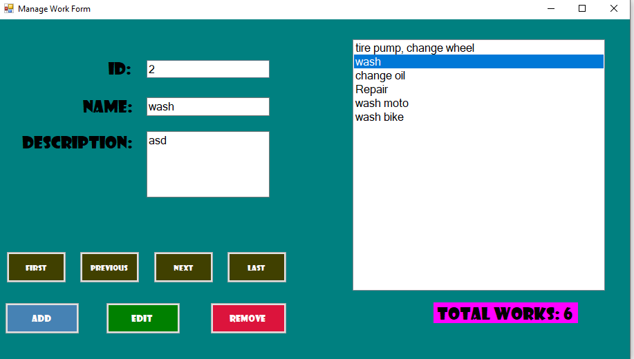Contract
   1. Caring contract detail
2. 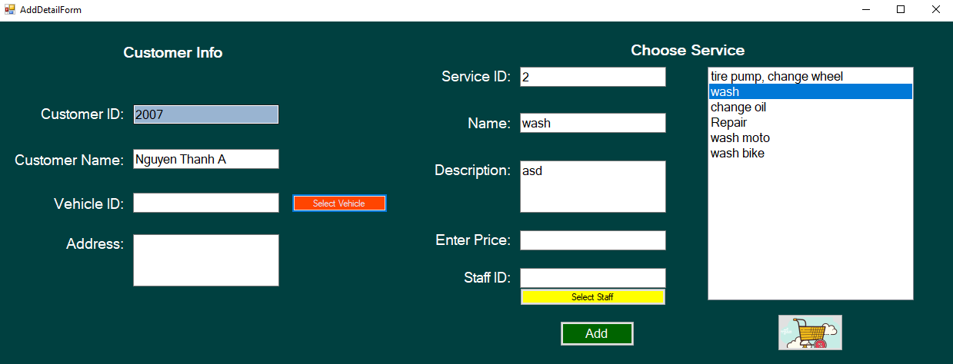Add detail: there are 2 zone, one for get customer information, one to choose service for the vehicle

At “Vehicle ID” field, we can use buton “Select Vehicle” to see more information about vehicle. Vehicle List form will appear

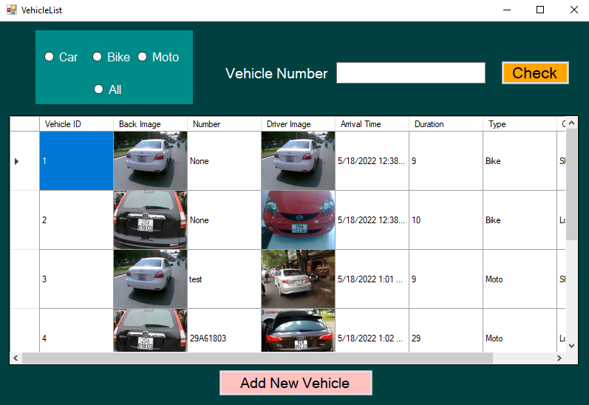

At “Staff ID” field we can click button “Select Staff” to see more information about staff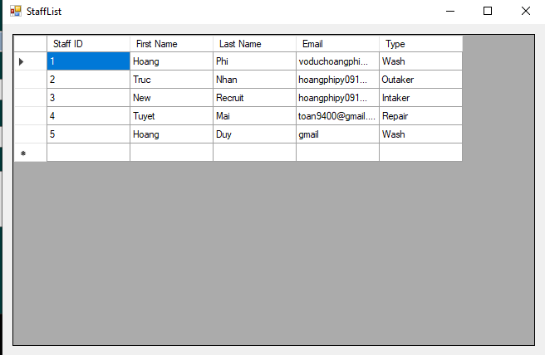

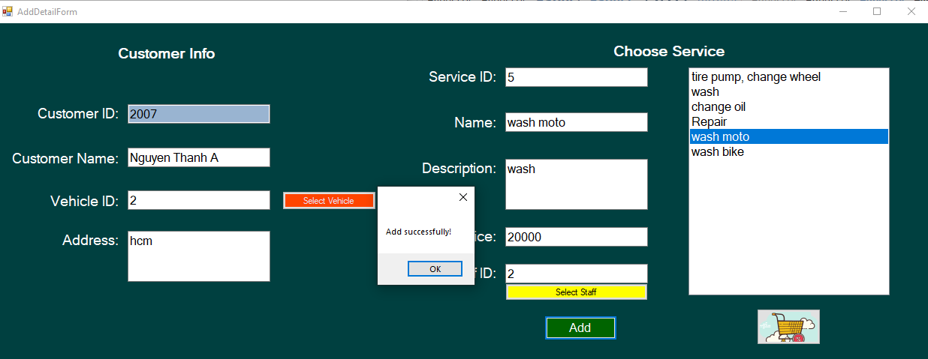After add successfully, we can see detail in detail form, click cart image to see

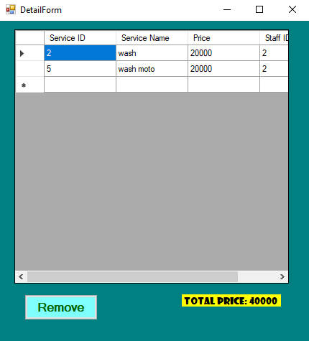

Click remove button to remove the choice

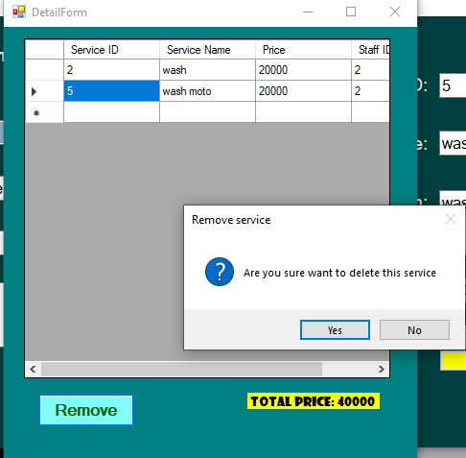

1. Remove contract detail

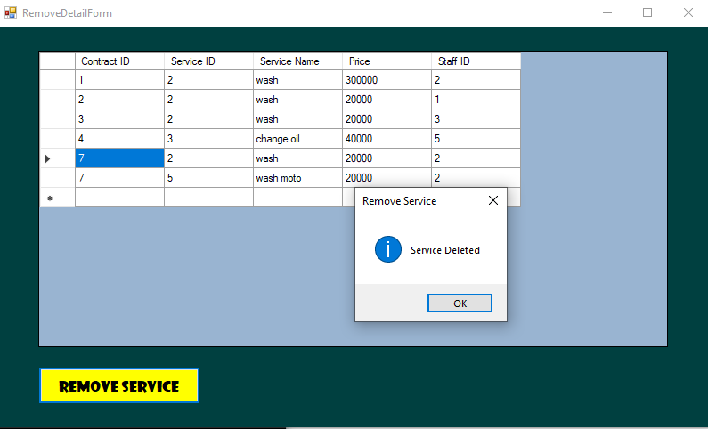

* 1. Caring Contract

1. List/Search by date or number

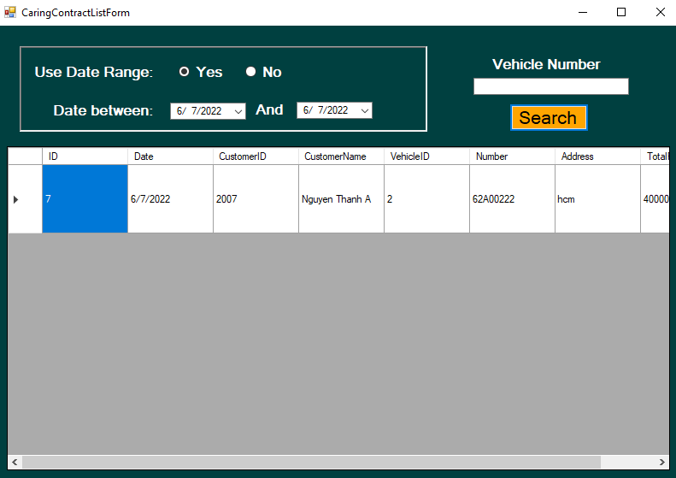

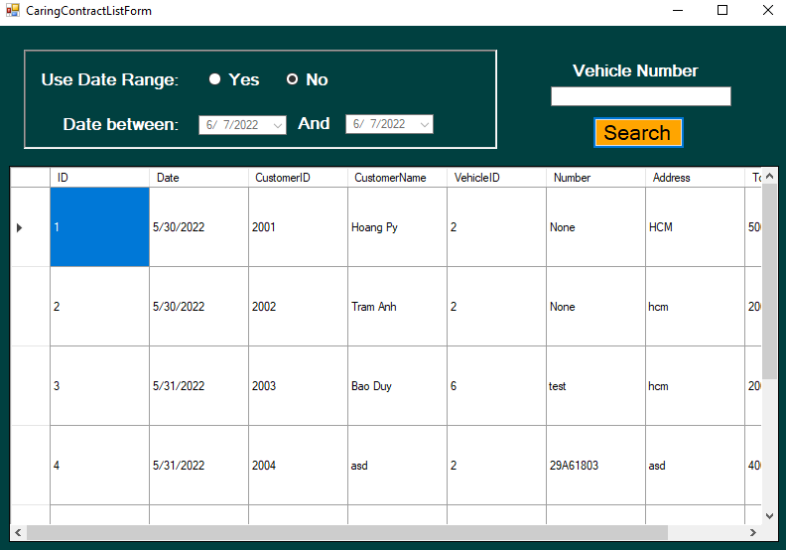

1. Remove Update Caring Contract

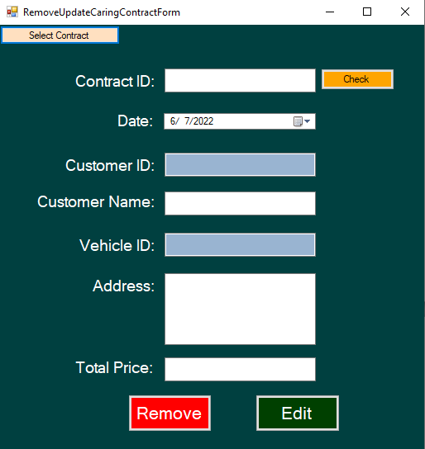

 Having “Select Contract” button to move to Contract List form

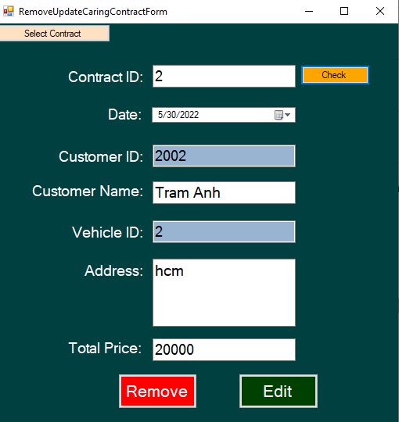Input Contract ID and click check it will fill all textbox like below:

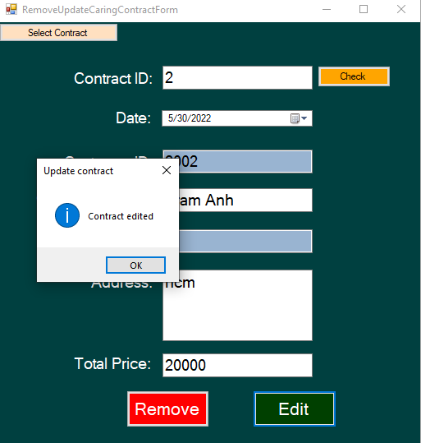Edit successfully:

Remove successfully:

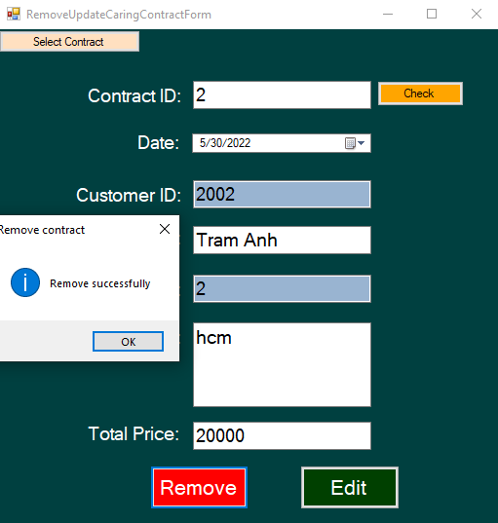

* 1. Rent Contract

Include:

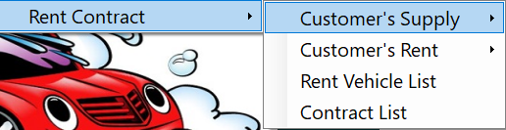

1. **Customer’s Supply** includes contract when customers supply vehicles for company.

* 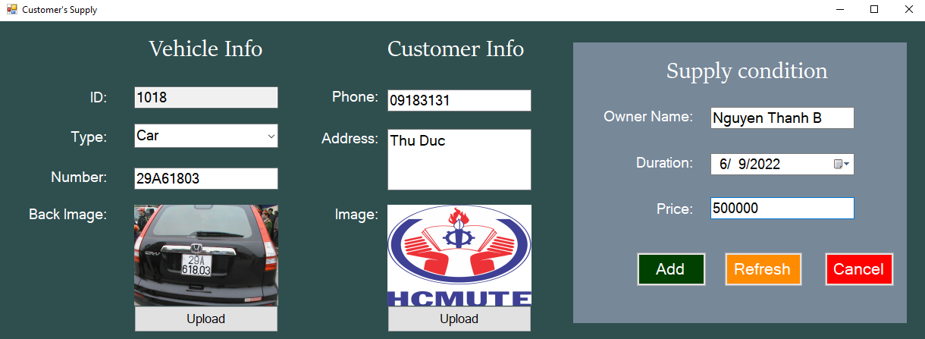**Supply Form**: add new contract to supply
* Check contract status:

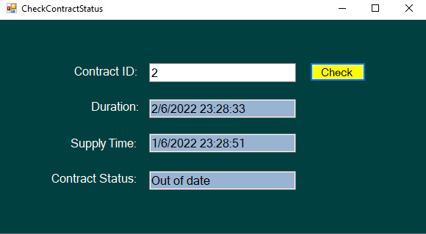

* End supply contract: end contract

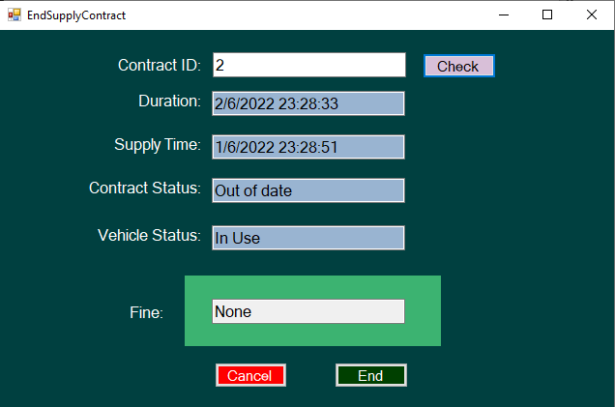

1. **Customer’s Rent:** includes contract when customers rent vehicles of company.

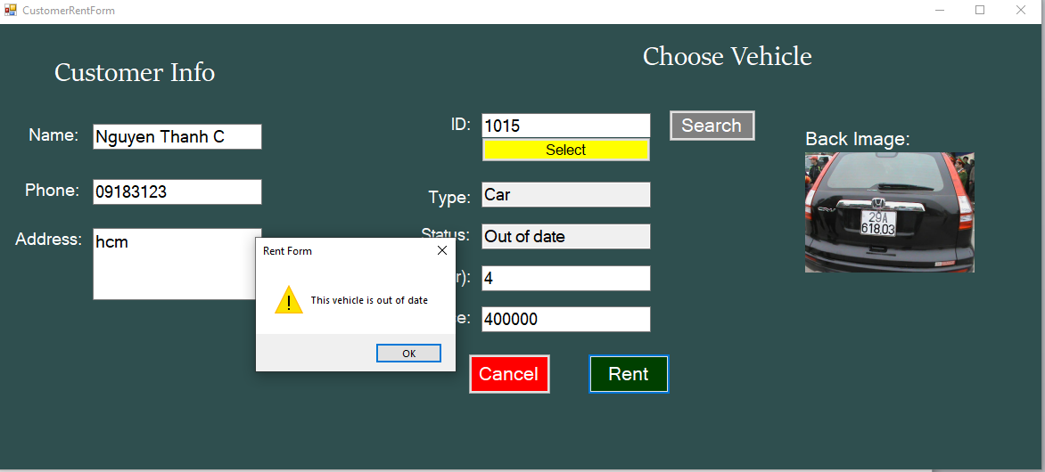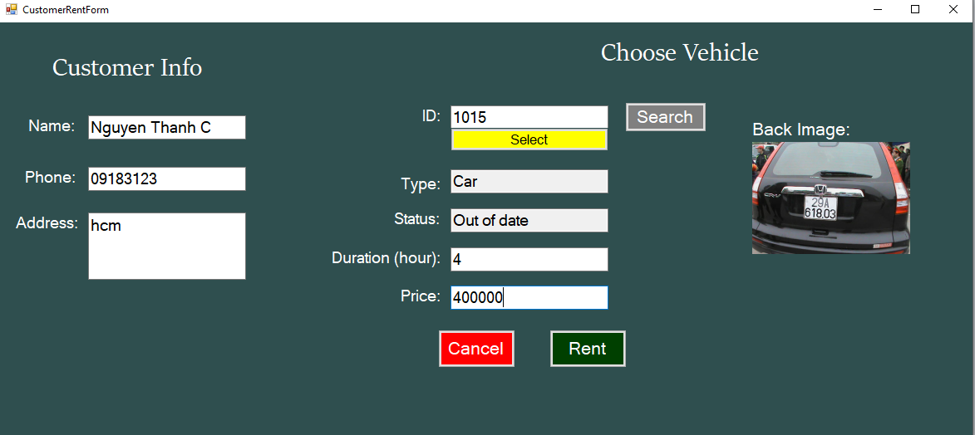Check status of vehicle before let customer rent it

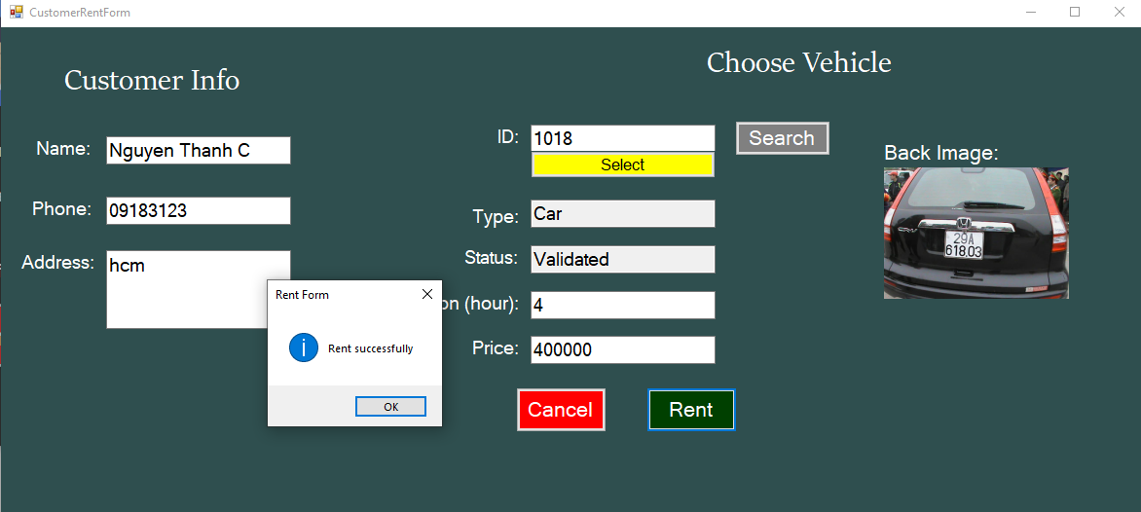

* 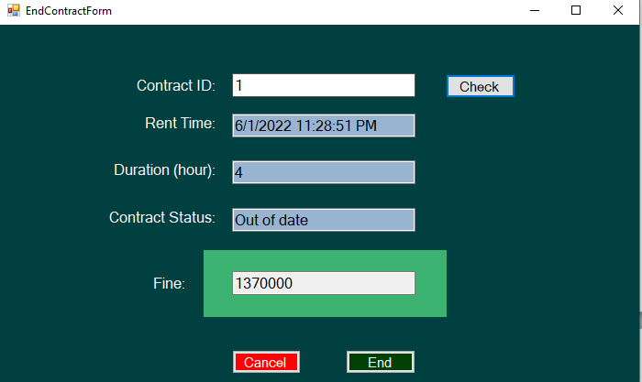End Rent Contract: check contract status, if out of date, get fine

1. Rent Vehicle List: include vehicle supplied by customers and company let others rent. Search by number and type of vehicle

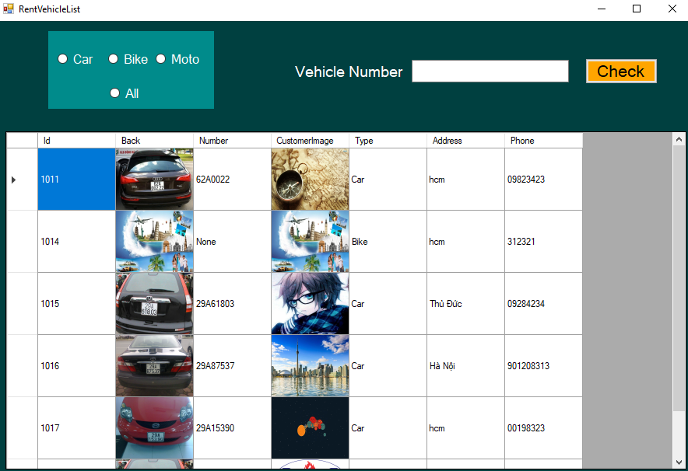

1. Contract List: include all information about supply contract and rent contract

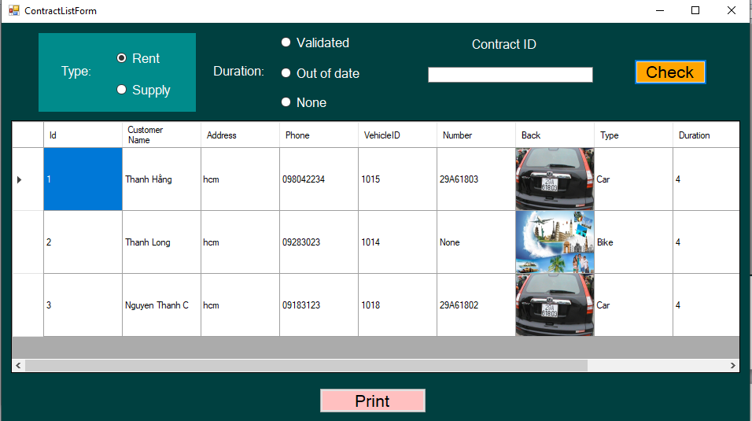Print: print a specific contract and save in word

